# 1.Introduction and Background

Since the fall of the Iron Curtain, Prague has become one of the world's most popular tourist destinations. Prague is classified as an "Alpha-" global city according to GaWC studies, comparable to Vienna, Manila and Washington, D.C. Prague ranked sixth in the Tripadvisor world list of best destinations in 2016.

Let’s say that worldwide hotel chain wants to open a new hotel in Prague, but is not sure of which neighbourhood it should choose. Before beginning this project, I looked up Prague hotels and found out that most of the hotels are clustered in the city centre, close to the river Vltava and to the commercial hubs with lots of shops, parks and other amenities.

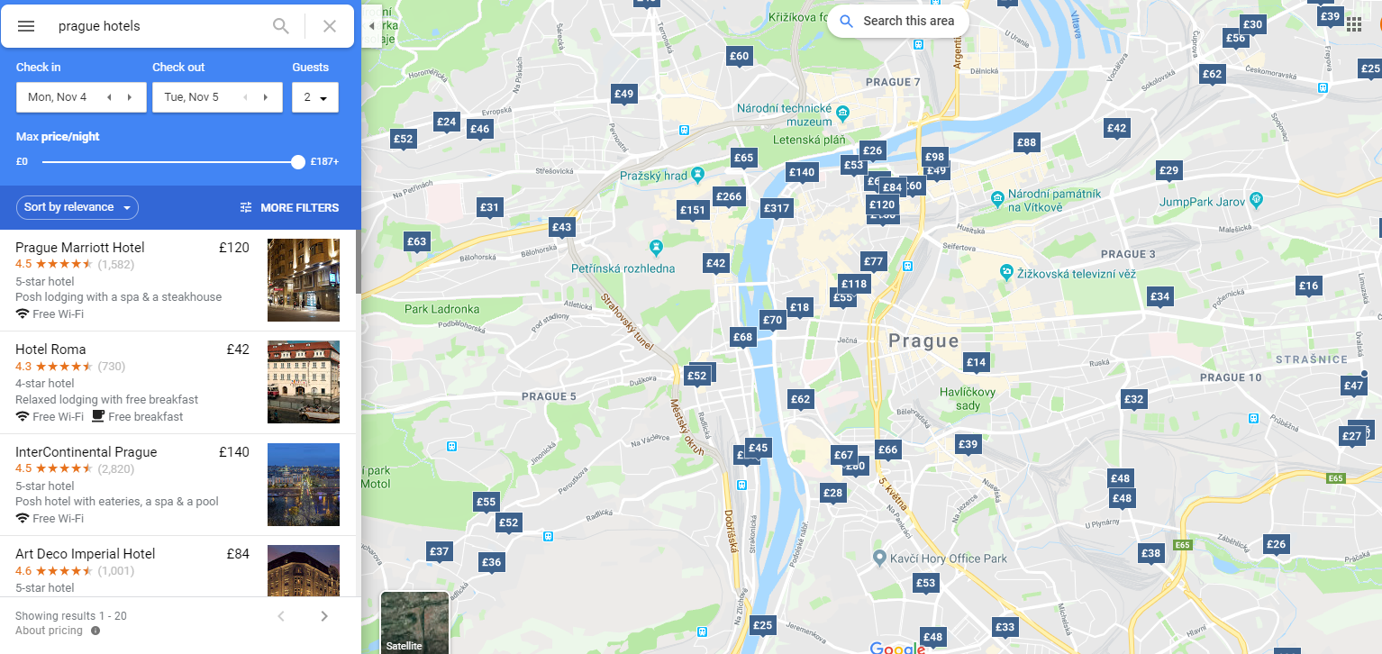

I thought of analysing which other Prague neighbourhood have a variety of different amenities and with low competition in terms of other hotels, as well as surrounding venues which match the target demographic of the hotel chain, i.e. tourist families. As a luxury hotel chain, they would be able to afford to open at popular venues as well.

The question is:

In the city of Prague, if a worldwide hotel chain targeting tourist families is planning to open a new hotel, where would you recommend they open it?

This data may prove useful to hotel chains who are looking to expand into Prague’s expanding tourism market, but also look at viable, but not overcrowded locations for their property.

# 2.Data

To solve this problem, I plan to use the following data:

1. List of neighbourhoods in Prague, which all serve as possible options for the hotel chain
2. Latitude and Longitude coordinates of each of these neighbourhoods, which would help visualise them and their surroundings on a map.
3. Venue data in order to locate parks, other hotels and surrounding venues that would help in the analysis.

# 3.Methodology

I plan to scrape data about the neighbourhoods in Prague from the Wikipedia page <https://en.wikipedia.org/wiki/Districts_of_Prague> and use Geocoder package to get coordinates for each of the neighbourhoods. Then I will use Foursquare API to get venue data of each neighbourhood, attractions, landmarks and other places to visit. Based on that data, I will gain insights to the number of amenities present in each neighbourhood. Using K-means clustering, I will calculate and cluster neighbourhoods which have a higher number of amenities and then visualise them using a map visualisation library called Folium. I will then check for hotels in these neighbourhoods and narrow down the list to neighbourhoods with low hotel competition. For each of the remaining neighbourhoods, I will calculate the 10 most common venues and judge which of them fit the target demographic of the hotel chain better and so concluding the best neighbourhood for opening a new hotel in Prague.

# 4.Results

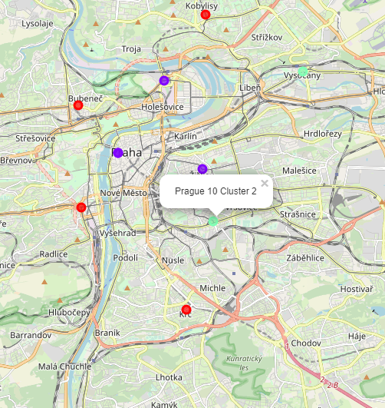

Neighbourhoods clustered around commercial hubs and parks.

Number of hotels in neighbourhoods that are close to parks.

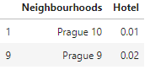

Top 10 venues in these neighbourhoods

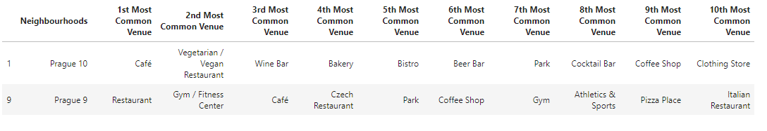

# 5.Discussion

From these observations, I thought that the given the target demographic of the hotel are tourist families, Prague 10 matches this demographic more than the other neighbourhoods. The presence of a train station and a bus stop close to the neighbourhood would be an important factor for tourists. Furthermore, cafes and restaurants are more common in this neighbourhood than others. Prague 9 would be a close second option, but Prague 10 has an advantage of being closer to the city centre, train and bus stop, which would make travel easier for tourists.

However, this data closely depends on the venues and data obtained from the Foursquare API with free account where number of calls is limited. Additional data should have been obtained on the other factors like safety and accessibility of the neighbourhood. Ii also discards neighbourhoods with a lot of parks and already existing hotels. These areas should be explored in the future.

# 6.Conclusion

Assuming the hotel is targeting tourist families with children, opening a parkside hotel would be highly recommended and Prague 10 would be ideal neighbourhood to open a new hotel.